Clinton Canoe Regatta: Looking at Histograms and Data Distribution
Downriver racing is a sport where competitors take their watercraft (usually a canoe, kayak, or stand-up paddle board) down a race course in competition with other paddlers. The General Clinton Canoe Regatta (nicknamed "the 70-miler") is a prominent race in the sport that has been running since the 1960s. The race is a 63 mile course down the Susquehanna River in New York (from Cooperstown to Bainbridge). Paddlers compete against each other to achieve the fastest time in their class, with the fastest boats finishing about 7-8 hours after they start.
Completing this race is an impressive feat, and this combined with the race’s fame means there is usually high attendance. However, unlike most races, where the turnout is mostly recreational paddlers, the difficulty of this race means that most paddlers at the General Clinton are pros. This phenomenon has interesting impacts on data from the race as pro boats are designed to be faster but also require more skill to maneuver effectively.
For this activity, each canoe is only included in the data once, regardless of the number of paddlers (which can typically range from 1-4) and canoes who were disqualified or who failed to finish have been removed from the data.
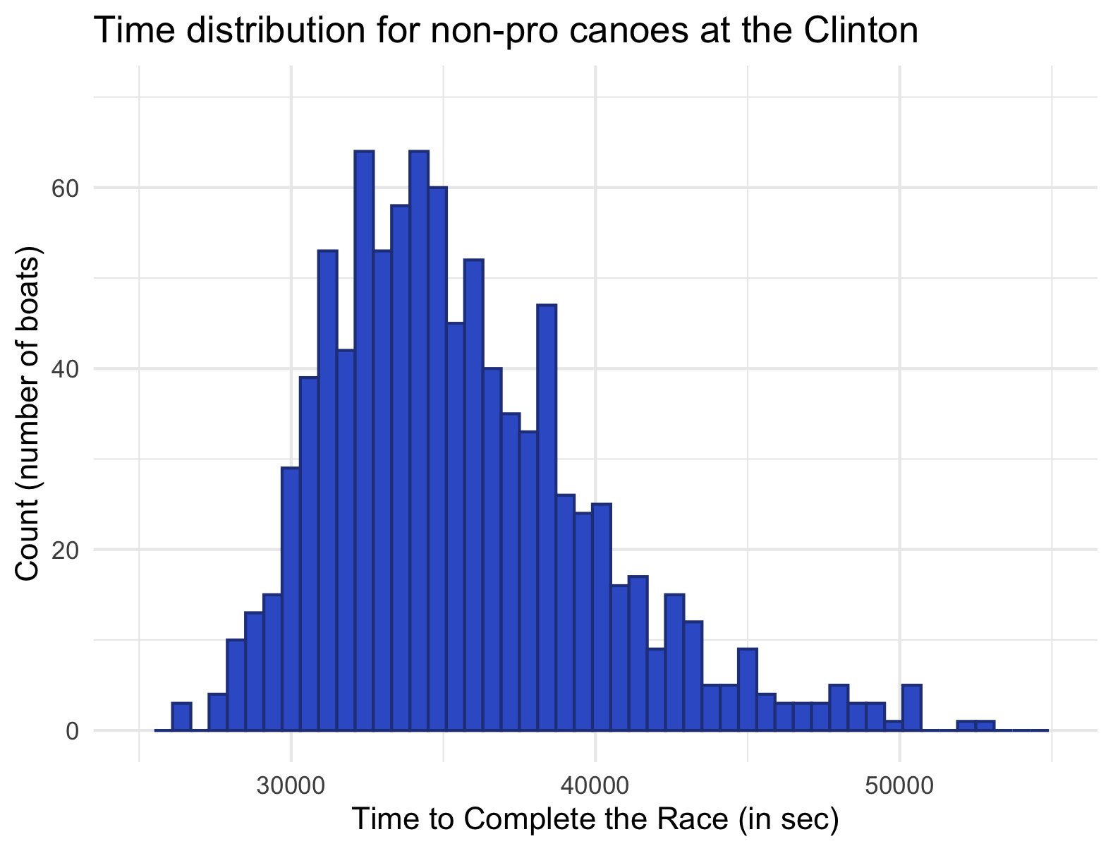
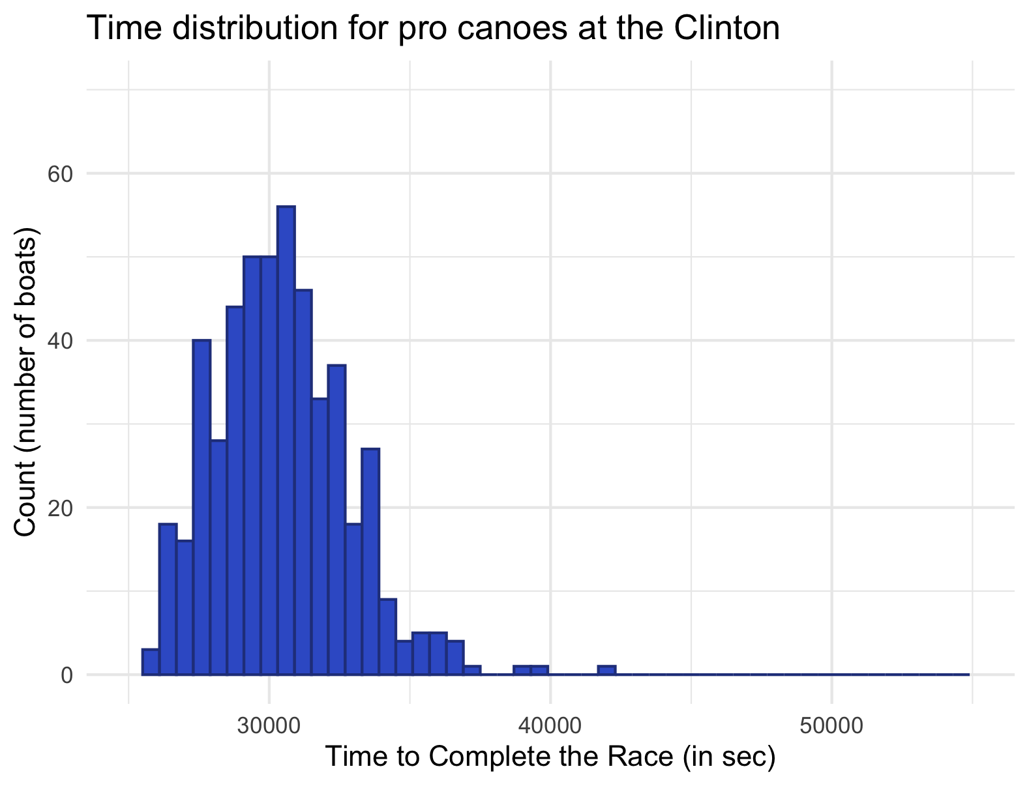
1. The histogram on the left shows the distribution of times on the Clinton from 2014-2025 for only the 497 pro canoes. The histogram on the right shows the distribution of times on the Clinton from 2014-2025 for all 954 canoes that are not pros. Use the histograms to complete the following activities.

- Describe the shape, spread, and center of the pro canoe data.

For the pro canoes, students should note that the data is fairly normally distributed (with a single mean). There does seem to be a small amount of skew to the right, but, for the most part, the data seems symmetrical and follows a normal bell curve. The mode seems to be a bit above 30,000 seconds (roughly 8 and a half hours). Most pro boats finish in between 25,000 seconds (about 7 hours) and 40,000 seconds (roughly 11 and a quarter hours).

- Describe the shape, spread, and center of the non-pro canoe data.

For the non-pro canoes, students should note that the data is noticeably right-skewed. Times for non-pros skew high. There are two very similar bars, so the mode could either be around 32,000 seconds (a bit under 9 hours) or around 35,000 seconds (about 9 hours 45 minutes). Most non-pro boats finish in between 25,000 seconds (about 7 hours) and 50,000 seconds (almost 14 hours).

- Based on the histograms, describe the differences between the distributions’ shapes. Use the context provided to propose a possible explanation of any differences you notice.

Students should primarily point out that the non-pro data is much more right-skewed and tends towards higher values. The mode and max values are noticeably larger for the non-pros. Explanations may differ, but based on the information given, students should mention that pro boats are faster, so it makes sense that their times, on average, reflect that. As for the skew difference, the pro class is less likely to have people who are simply doing the race to do the race (and who are not trying as hard) and more likely to have people who have trained or done similar races (or even this race) before. This makes them less likely to have any boats with unusually high times.

2. The following table shows the summary statistics for the pro and non-pro data. Use it to complete the following activities:
 | Pro | Non-Pro
Mean | 30420.13 | 35565.78
SD | 2361.809 | 4417.876
Min | 25899 | 26501
1Q | 28760 | 32404
Median | 30283 | 34817.5
3Q | 31840 | 38156.5
Max | 41761 | 52967

- Compare the measures of center and the spreads. Again, use the context provided to propose a possible explanation of any differences you notice.

Students should notice that, unexpectedly, the mean and median for the non-pro boats are higher than those for the pro boats. This can be explained by the lightness and speed of the pro boat design and most likely the higher experience level of the paddlers. Again, students should point out the extreme difference in spreads for the two categories. The spread for the non-pros is much larger (26,466 vs. 15,862), supported by the comparative size of the standard deviation. This greater variability and higher spread can most likely be attributed to the fact that the pro boat category only encompasses one class of boat/paddlers (the pros) whereas the non-pro category is made up of all canoes that are not pro boats. There is a wide variety of people and boats in this category, leading to a large variety of times.

- Sketch a boxplot (with no outliers) of the data with pro vs. non-pro as the boxes and completion time for the race on the y axis.
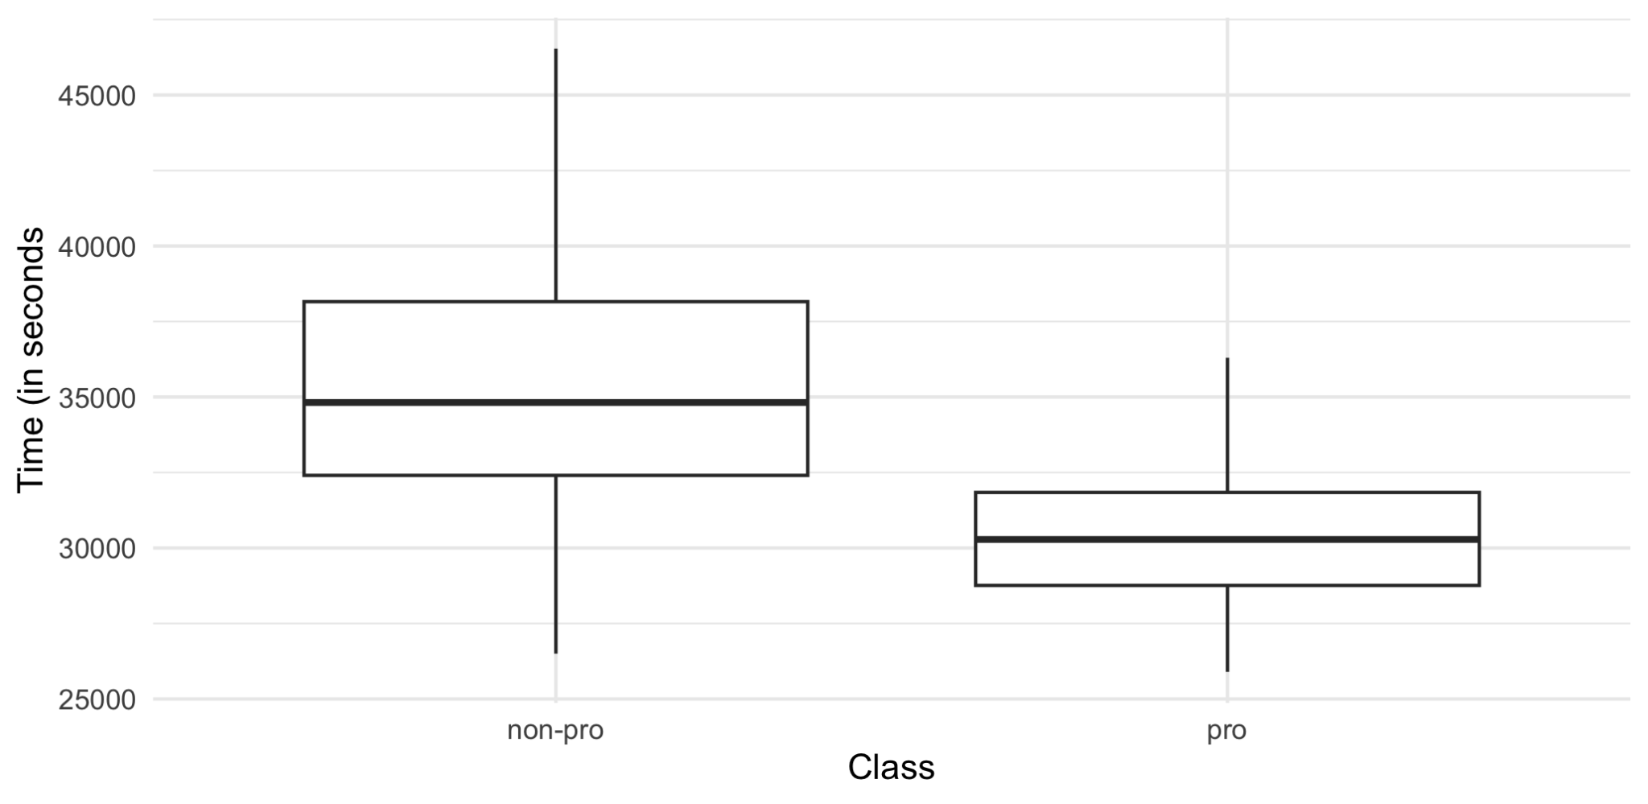

3. In 2025, Adam Blanchard and Rebecca Sutton placed first in the C2 Stock (not pro) Mixed class with a time of 8 hours, 32 minutes, and 21 seconds (30741 seconds). In the same year, Dean Brown & Chris Prater placed 40th in the pro class with a time of 8 hours, 3 minutes and 11 seconds (28991 seconds). Which of these times is better (relatively)? How did you draw your conclusion?

Answers to this question may vary. Students may use z-scores, distance from the mean, or judgement calls based on the plots to make this call. One thing a student may say is that Dean and Chris’s time is 1,429.13 seconds from the mean time for pro boats and Adam and Rebecca’s time is 4,824.78 seconds from the mean time for non-pro times. By this logic (and most), Adam and Rebecca’s time is better relative to the expectations.

